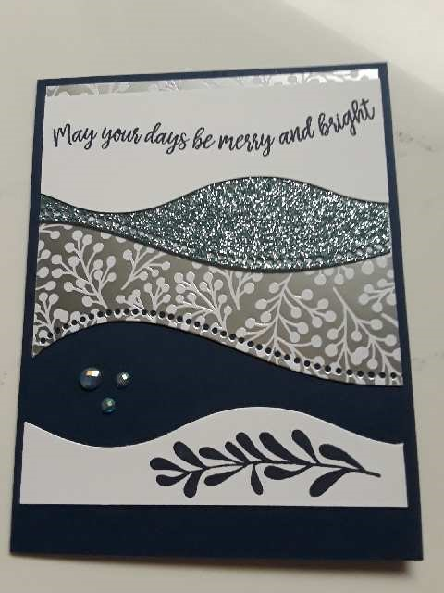
Curvy Christmas

I used “Night of Navy Cardstock” for the card base: 5-1/2 x 8-1/2. Scored at 4-1/4.
I used “Balmy Blue Glimmer Paper” for one of the layers.
"White Cardstock” scraps for the sentiment & leaf border at the bottom.
I used “Feels Like Frost” DSP.
I used “Blue Adhesive Backed Gems”.
I used “Curvy Christmas Stamp Set”.
I used the “Quite Curvy” Bundle Dies to die cut the layers.
Use my card for inspiration or copy it. This card can be made with many different colors, papers & gems. The sky is the limit, have fun with it!

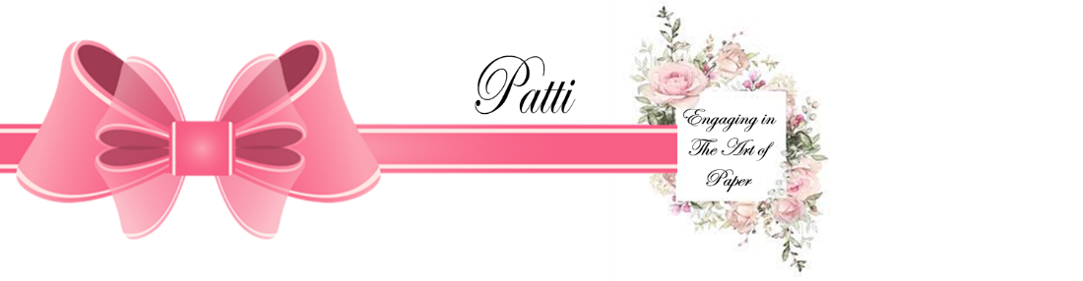
Mypatti.com

