BABY GIRL CARD
mypatti.com
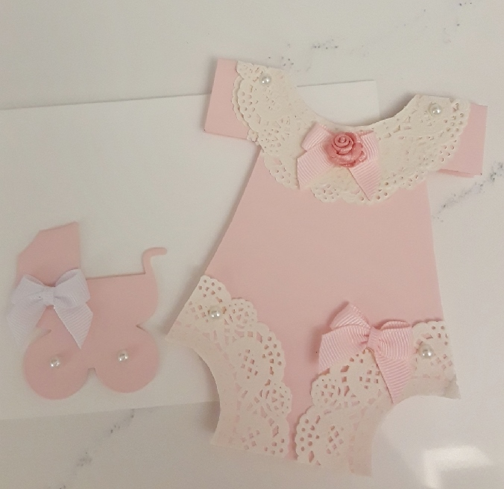
Cardstock: Cut at 10-1/2” x 4”

Score at: 5-1/4”.

Mark the middle at 2”.

Mark 1” down on both sides.

From the 1” mark draw a line ¾” in on both sides.

Circle Punches Needed: 2” and 1-3/4”.

Punch the top of the card with the 2” circle punch.

Punch the bottom sides with the 1-3/4” circle punch.

Cut the card from the bottom corner up to the ¾” line that you drew.

Decorate however you want. I used doilies, pearl embellishments & ribbons.

